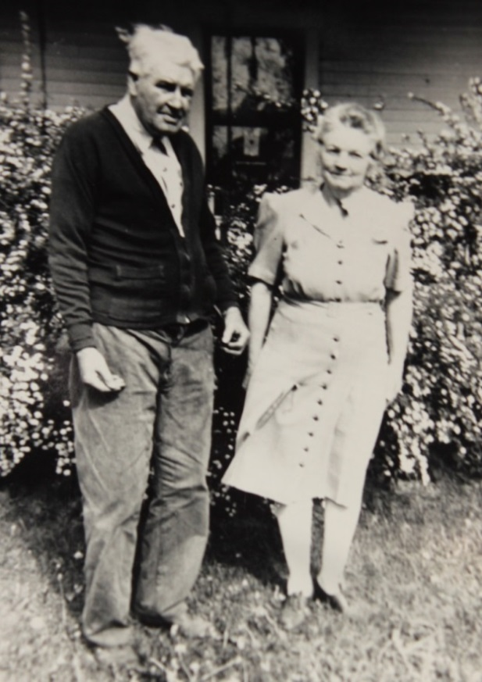

Earl Russell and Josephine Sybil Worthen Wolfe – about 1947 (est.)

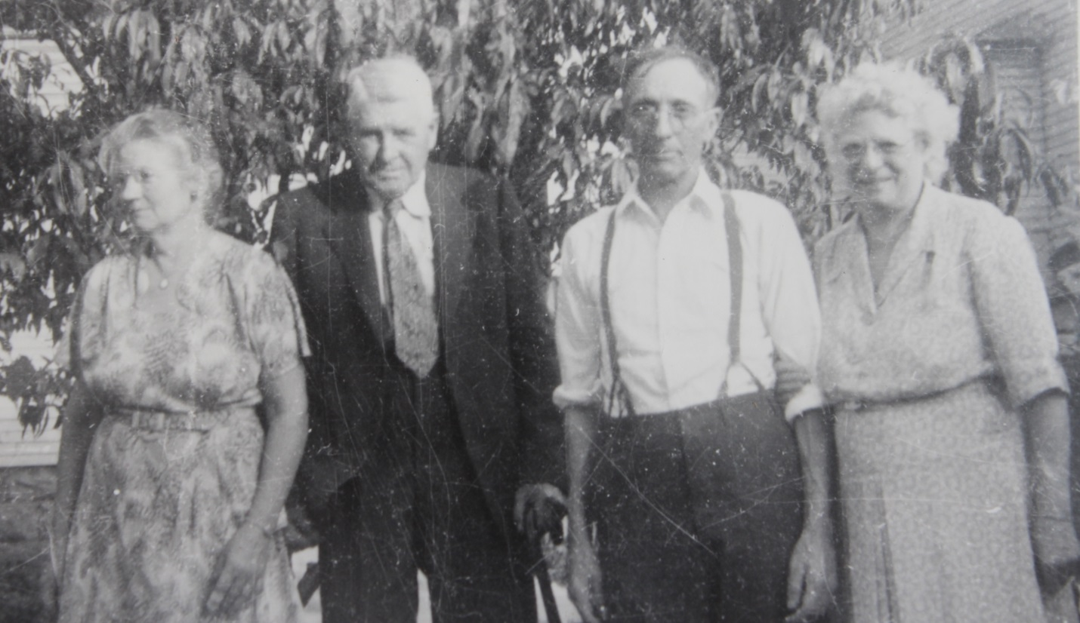

Josephine S. Worthen Wolfe, Earl R. Wolfe, Charles Allen Worthen & wife,

Mary P. Sluth Worthen - about 1948 (est.)